# EXERCISE 5 – ANDROID APPLICATION THAT CREATES ALARM CLOCK

##### Aim:

To develop a Android Application that creates Alarm Clock.

##### Procedure:

**Creating a New project:**

* + Open Android Studio and then click on **File -> New -> New project.**

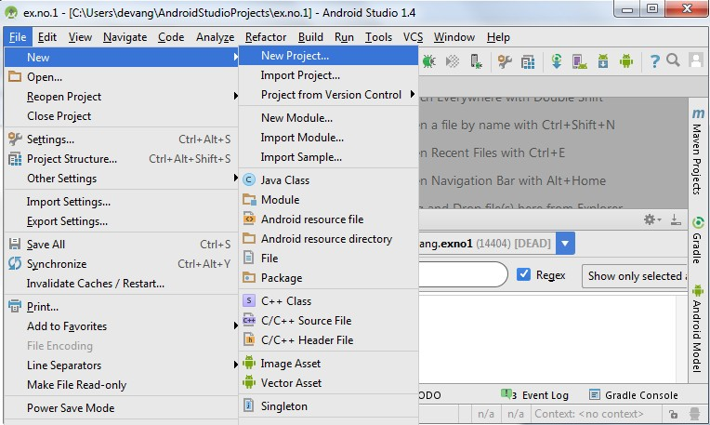

* + Then type the Application name as “**ex.no.11″** and click **Next.**

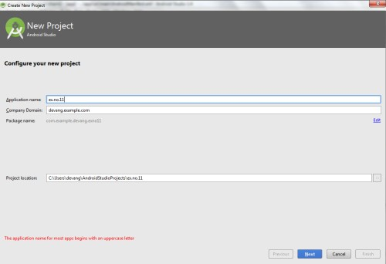

* + Then select the **Minimum SDK** as shown below and click **Next**.

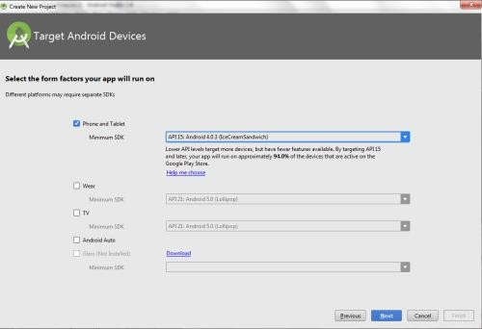

* + Then select the **Empty Activity** and click **Next.**

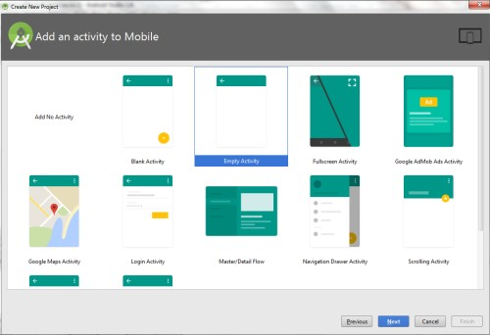

* + Finally click F**inish**.

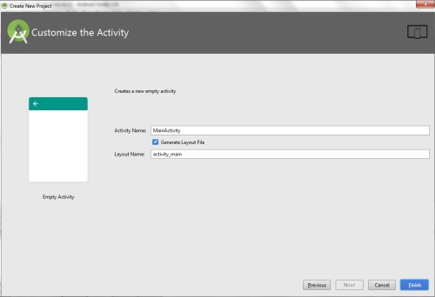

* + It will take some time to build and load the project.
  + After completion it will look as given below.

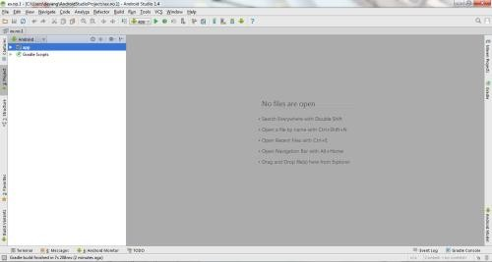

**Creating Second Activity for the Android Application:**

* + Click on **File -> New -> Activity -> Empty Activity.**

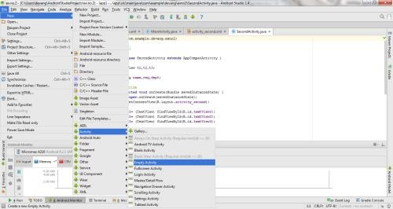

* + Type the Activity Name as **AlarmReceiver** and click **Finish** button.

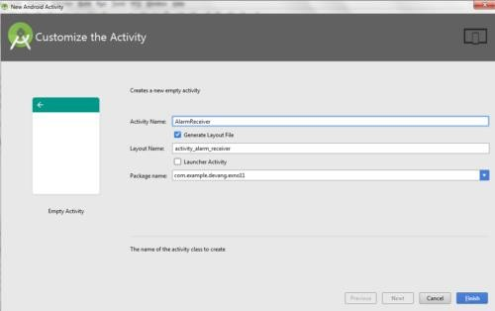

* + Thus Second Activity For the application is created.

**Designing layout for the Android Application:**

* + Click on **app -> res -> layout -> activity_main.xml.**

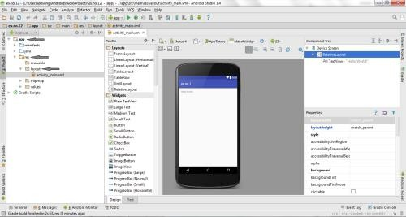

* + Now click on **Text** as shown below.

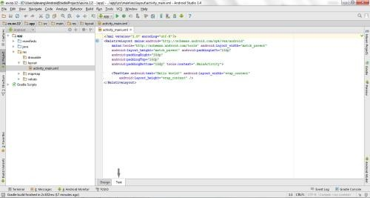

* + Then delete the code which is there and type the code as given below.

##### Code for Activity_main.xml:

<?xml version="1.0" encoding="utf-8"?>

<LinearLayout [xmlns:android="http://schemas.android.com/apk/res/android"](http://schemas.android.com/apk/res/android) android:layout_width="match_parent" android:layout_height="match_parent" android:orientation="vertical">

<TimePicker

android:id="@+id/timePicker" android:layout_width="wrap_content" android:layout_height="wrap_content" android:layout_gravity="center" />

<ToggleButton

android:id="@+id/toggleButton" android:layout_width="wrap_content" android:layout_height="wrap_content" android:layout_gravity="center" android:layout_margin="20dp" android:checked="false" android:onClick="OnToggleClicked" />

</LinearLayout>

* + Now click on **Design** and your application will look as given below.

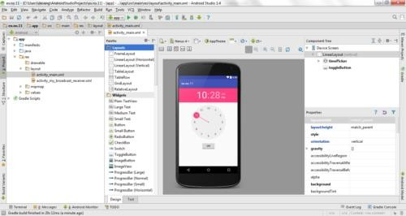

* + So now the designing part is completed.

**Changes in Manifest for the Android Application:**

* + Click on **app -> manifests -> AndroidManifest.xml**

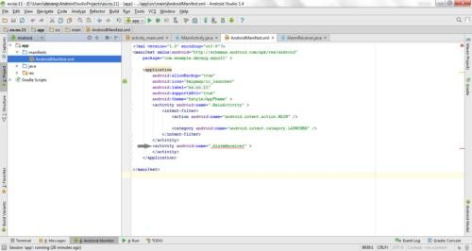

* + Now change the **activity tag** to **receiver tag** in the AndroidManifest.xml file as shown below

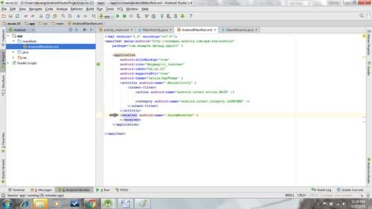

**Code for AndroidManifest.xml:**

<?xml version="1.0" encoding="utf-8"?>

<manifest [xmlns:android="http://schemas.android.com/apk/res/android"](http://schemas.android.com/apk/res/android) package="com.example.exno11" >

<application

android:allowBackup="true" android:icon="@mipmap/ic_launcher" android:label="@string/app_name" android:supportsRtl="true" android:theme="@style/AppTheme" >

<activity android:name=".MainActivity" >

<intent-filter>

<action android:name="android.intent.action.MAIN" />

<category android:name="android.intent.category.LAUNCHER" />

</intent-filter>

</activity>

<receiver android:name=".AlarmReceiver" >

</receiver>

</application>

</manifest>

**Java Coding for the Android Application:**

***Java Coding for Main Activity:***

* + Click on **app -> java -> com.example.exno11 -> MainActivity.**

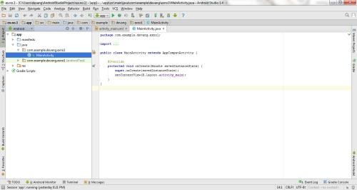

* + Then delete the code which is there and type the code as given below.

## Code for MainActivity.java:

package com.example.exno11;

import android.app.AlarmManager; import android.app.PendingIntent; import android.content.Intent; import android.os.Bundle;

import android.support.v7.app.AppCompatActivity; import android.view.View;

import android.widget.TimePicker; import android.widget.Toast;

import android.widget.ToggleButton; import java.util.Calendar;

public class MainActivity extends AppCompatActivity

{

TimePicker alarmTimePicker; PendingIntent pendingIntent; AlarmManager alarmManager;

@Override

protected void onCreate(Bundle savedInstanceState)

{

super.onCreate(savedInstanceState); setContentView(R.layout.activity_main);

alarmTimePicker = (TimePicker) findViewById(R.id.timePicker); alarmManager = (AlarmManager) getSystemService(ALARM_SERVICE);

}

public void OnToggleClicked(View view)

{

long time;

if (((ToggleButton) view).isChecked())

{

Toast.makeText(MainActivity.this, "ALARM ON", Toast.LENGTH_SHORT).show();

Calendar calendar = Calendar.getInstance();

calendar.set(Calendar.HOUR_OF_DAY, alarmTimePicker.getCurrentHour());

calendar.set(Calendar.MINUTE, alarmTimePicker.getCurrentMinute()); Intent intent = new Intent(this, AlarmReceiver.class); pendingIntent = PendingIntent.getBroadcast(this, 0, intent, 0);

time=(calendar.getTimeInMillis()- (calendar.getTimeInMillis()%60000));

if(System.currentTimeMillis()>time)

{

if (calendar.AM_PM == 0)

time = time + (1000*60*60*12); else

time = time + (1000*60*60*24);

}

alarmManager.setRepeating(AlarmManager.RTC_WAKEUP, time, 10000, pendingIntent);

}

else

{

alarmManager.cancel(pendingIntent); Toast.makeText(MainActivity.this, "ALARM OFF",

Toast.LENGTH_SHORT).show();

}

}

}

* + So now the Coding part of Main Activity is completed.

***Java Coding for Alarm Receiver:***

* + Click on **app -> java -> com.example.exno11 -> AlarmReceiver.**

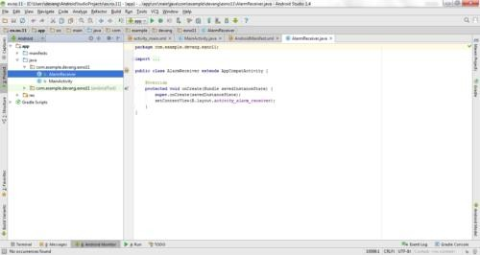

* + Then delete the code which is there and type the code as given below.

##### Code for AlarmReceiver.java:

package com.example.exno11;

import android.content.BroadcastReceiver; import android.content.Context;

import android.content.Intent; import android.media.Ringtone;

import android.media.RingtoneManager; import android.net.Uri;

import android.widget.Toast;

public class AlarmReceiver extends BroadcastReceiver

{

@Override

public void onReceive(Context context, Intent intent)

{

Toast.makeText(context, "Alarm! Wake up! Wake up!", Toast.LENGTH_LONG).show();

Uri alarmUri = RingtoneManager.getDefaultUri(RingtoneManager.TYPE_ALARM);

if (alarmUri == null)

{

alarmUri = RingtoneManager.getDefaultUri(RingtoneManager.TYPE_NOTIFICATION);

}

Ringtone ringtone = RingtoneManager.getRingtone(context, alarmUri); ringtone.play();

}

}

* + So now the Coding part of Alarm Receiver is also completed.
  + Now run the application to see the output.

##### Output:

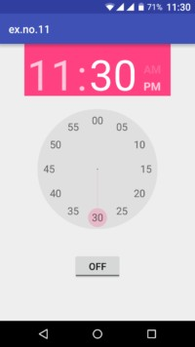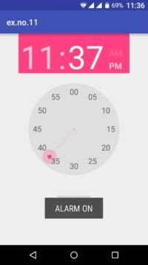

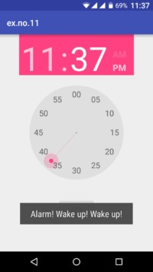 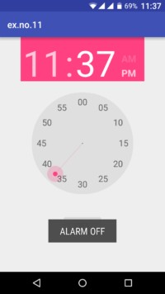

##### Result:

Thus Android Application that creates Alarm Clock is developed and executed successfully.

**EXERCISE 10.1:** [05]

Develop an android application to Alarm a clock and a button to off the alarm.

**EXERCISE 10.2:** [05]

Develop an android application to capture a photo from your mobile.



##### RESOURCES:

<https://www.codingconnect.net/mobile-application-development-lab/> <https://www.javatpoint.com/android-tutorial> <https://www.tutorialspoint.com/android> <https://developer.android.com/guide> [Https://developer.Android.com/training/basics/firstapp/creating-project](https://developer.android.com/training/basics/firstapp/creating-project)

[Https://www.raywenderlich.com/120177/beginning-Android-development-tutorial-](https://www.raywenderlich.com/120177/beginning-Android-development-tutorial-installingAndroid-studio) [installingAndroid-studio](https://www.raywenderlich.com/120177/beginning-Android-development-tutorial-installingAndroid-studio) <https://www.youtube.com/playlist?list=PLS1QulWo1RIbb1cYyzZpLFCKvdYV_yJ-E> [Https://www.udemy.com/java-tutorial/](https://www.udemy.com/java-tutorial/)

[Https://www.w3schools.com/xml/](https://www.w3schools.com/xml/) [Http://www.Androidguys.com/](http://www.androidguys.com/)